DSA

UNIT 3

1. **Write an algorithm for depth first traversal of a graph**

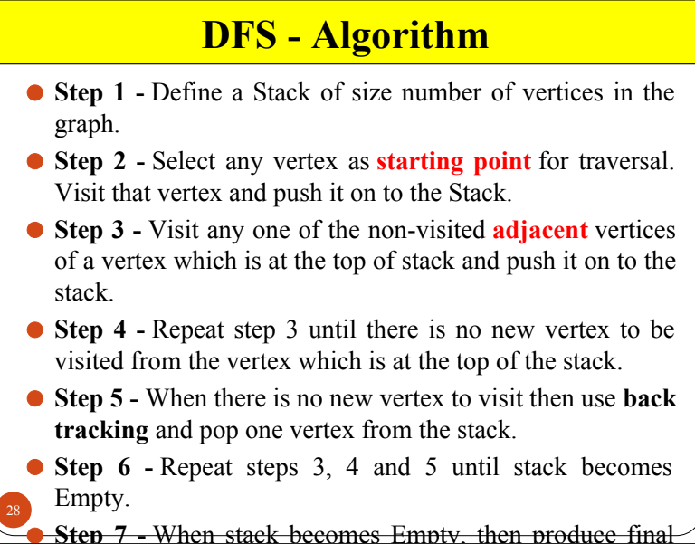

1. **Construct the minimum spanning tree (MST) for the given graph using Prim’s Algorithm staring from vertex 6.**

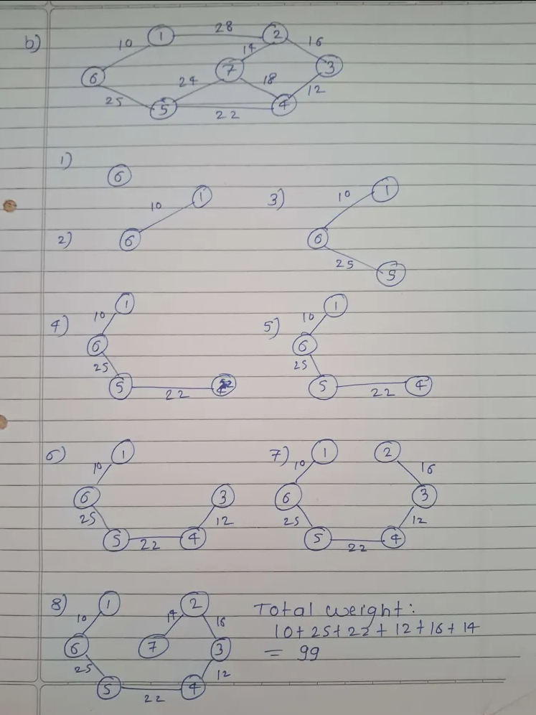

1. **What is topological sorting? Find topological sorting of given graph.**

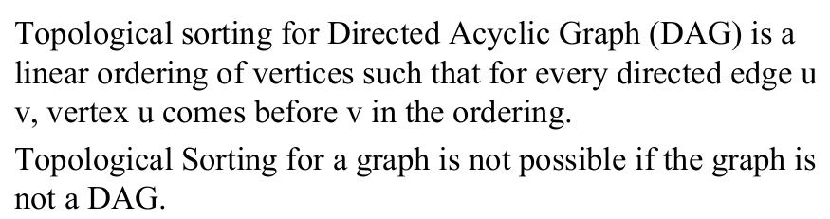

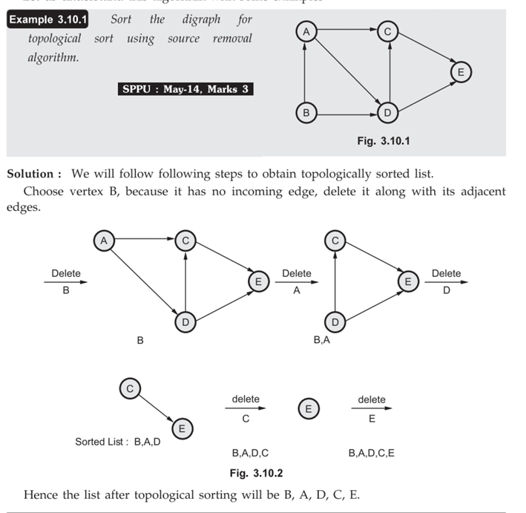

1. **Write an algorithm for breadth first traversal of a graph.**

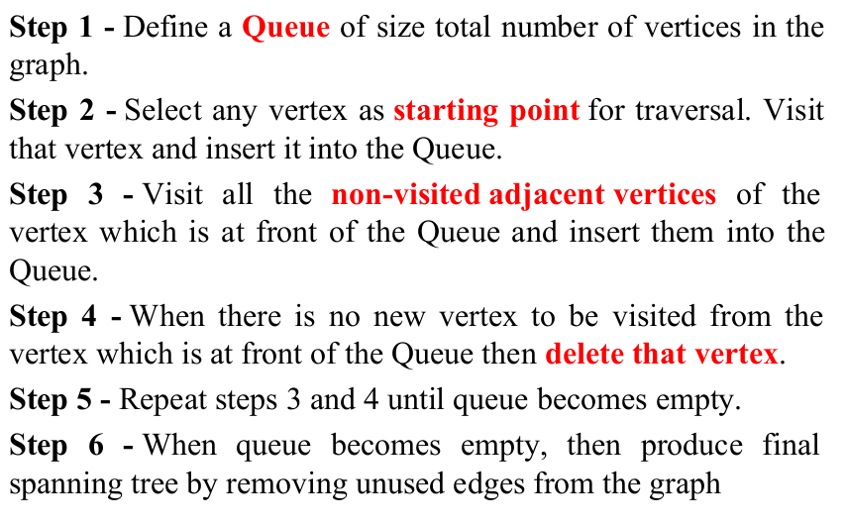

1. **Using Prim’s Algorithm, find the cost of minimum spanning tree (MST) of the given graph starting from vertex ‘a’**

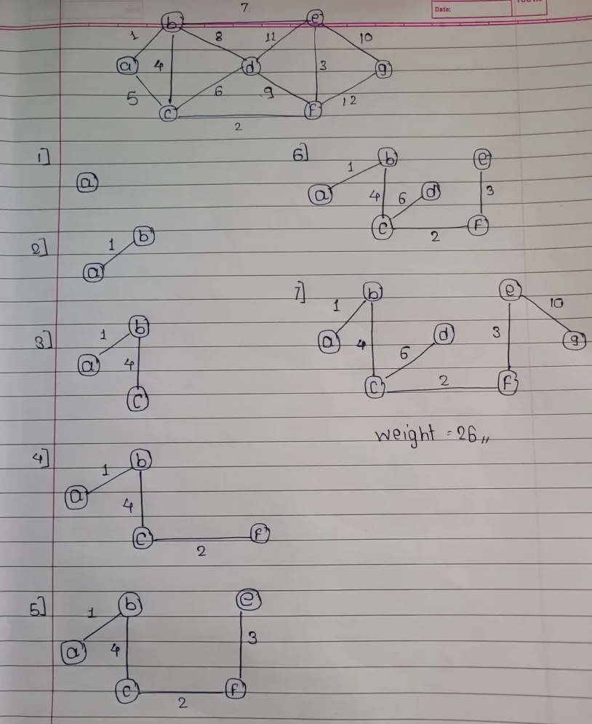

1. 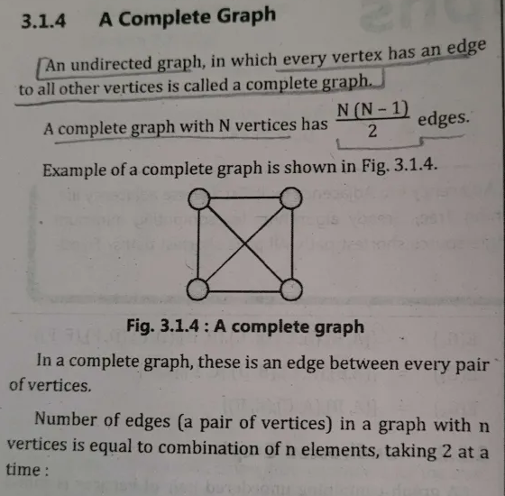**Define the following terms : i) Complete Graph ii) Connected Graph iii) Subgraph**

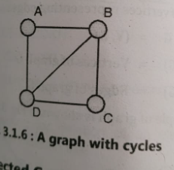

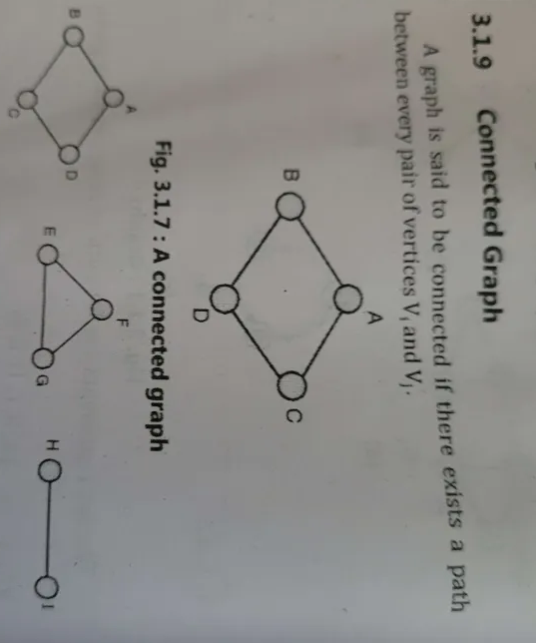

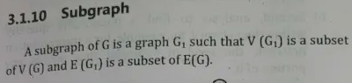

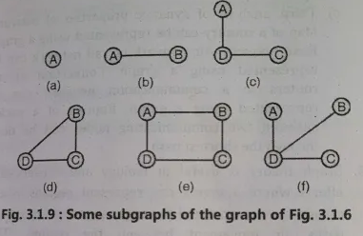

1. **Write Floyd Warshall Algorithm**

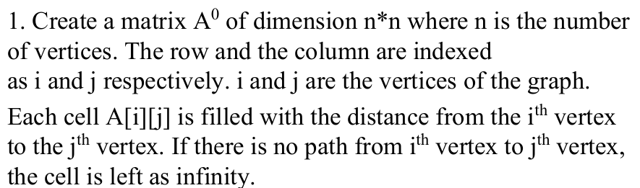

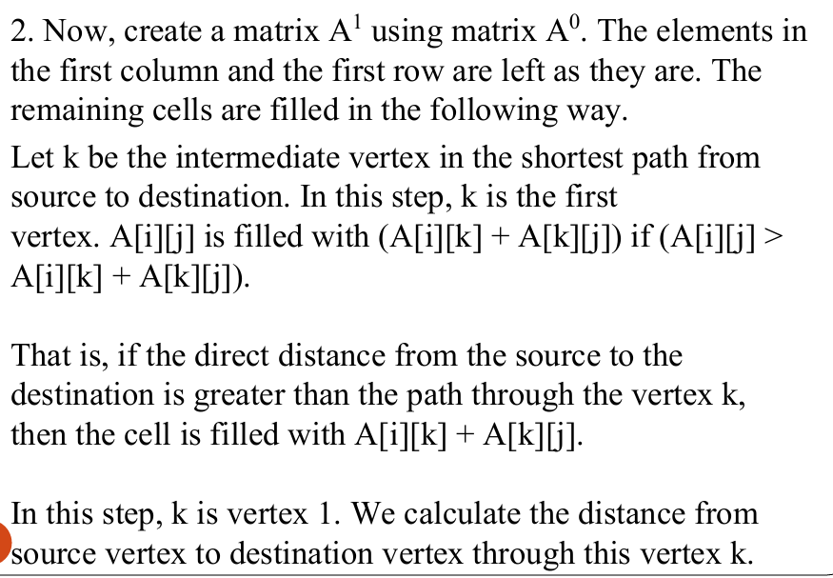

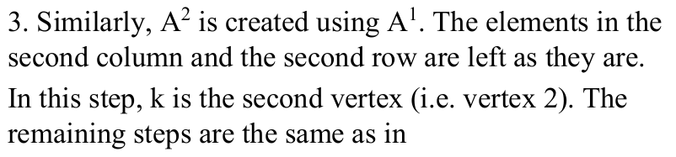

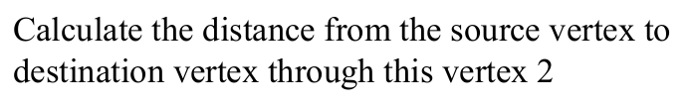

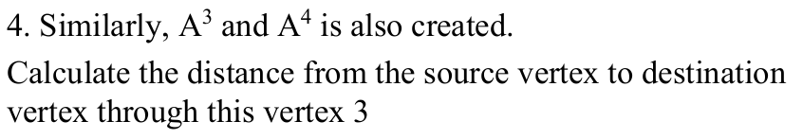



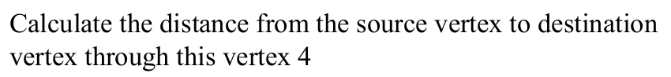

1. **Apply Dijkstra’s Algorithm for the graph given below, and find the shortest path from node A to node C.**

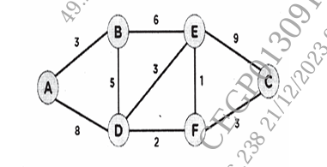

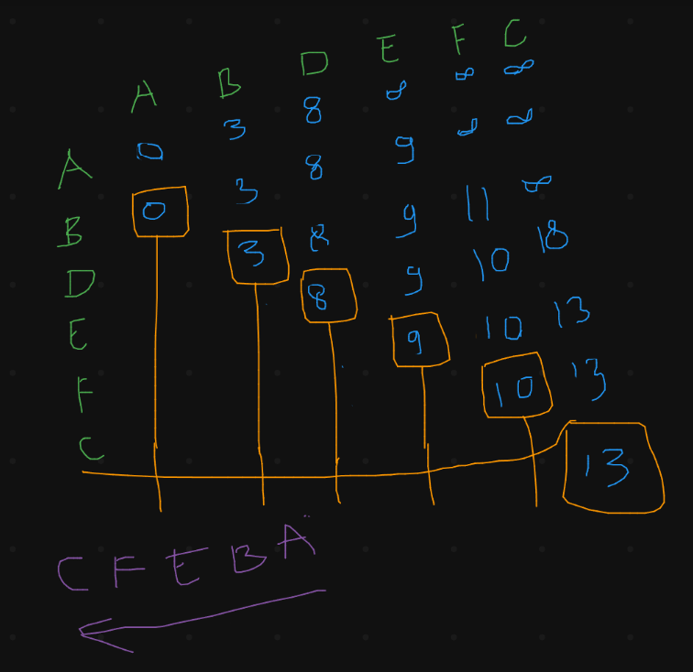

1. **Define indegree & outdegree of a directed graph. Write degree for G1 & G2. Write indegree & outdegree of each vertex for G3 graph.**

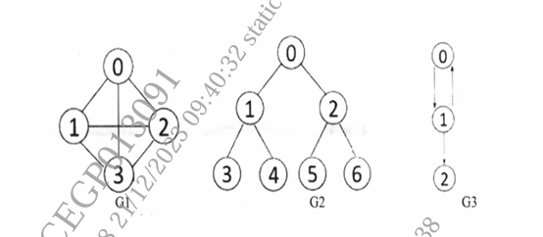

1. **Construct the minimum spanning tree (MST) for the given graph using Kruskal’s Algorithm.**

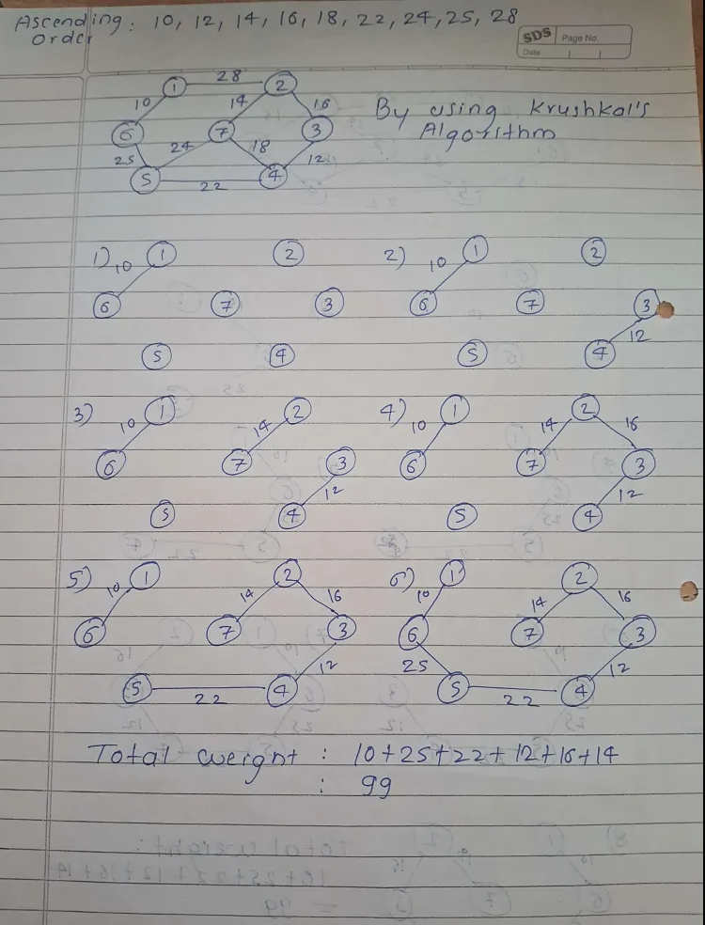

1. **Find the number of different topological orderings possible for the given graph**

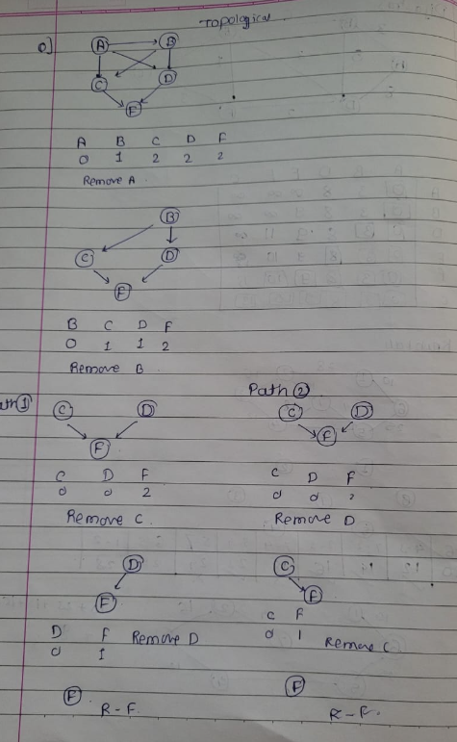

1. **Elaborate following terminologies : i) Graph ii) Adjacency List iii) Adjacency Matrix**

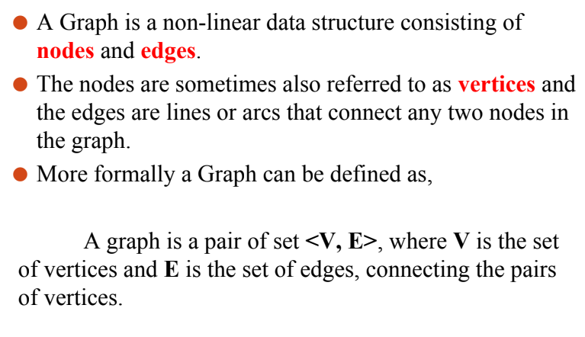

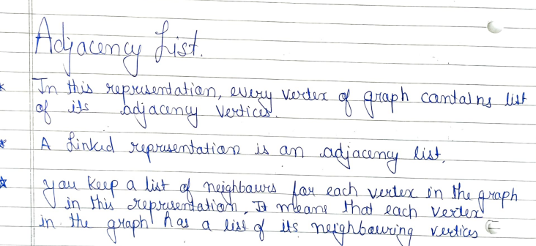

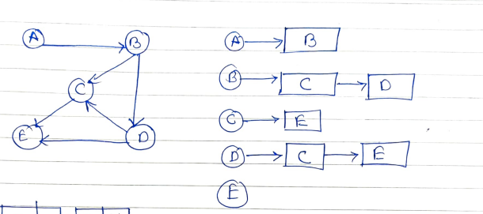

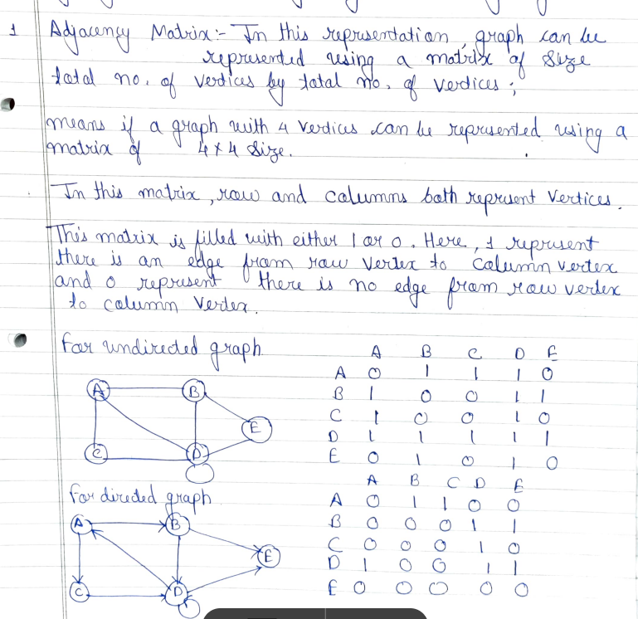

1. **Differentiate between tree and graph**

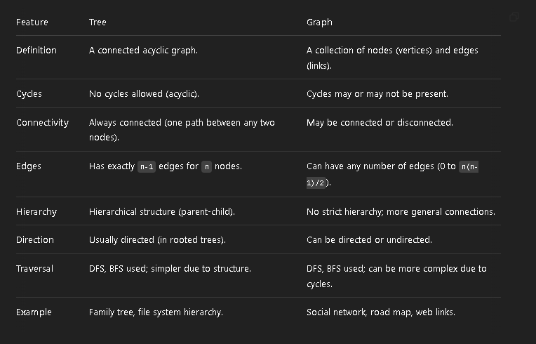

1. **Write pseudo code for Floyd-Warshall algorithm.**

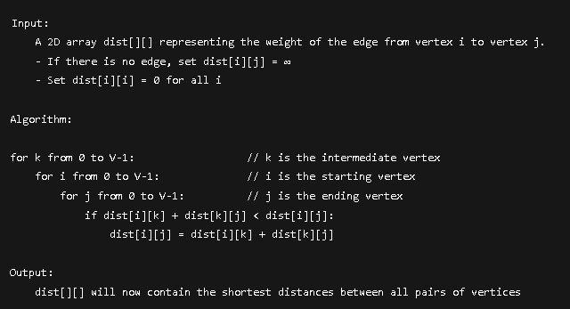

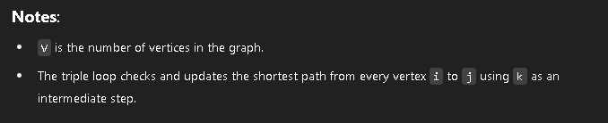

1. **Write Prim’s algorithm to find minimum spanning tree**

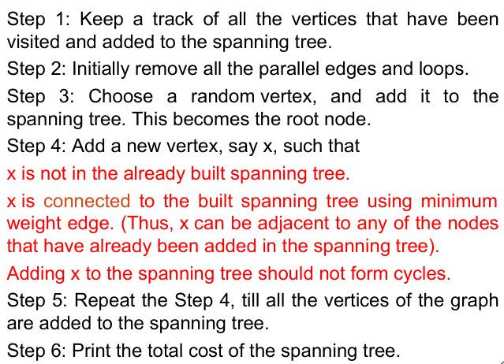

1. **Write the applications of : i) Graph ii) BFS iii) DFS**



